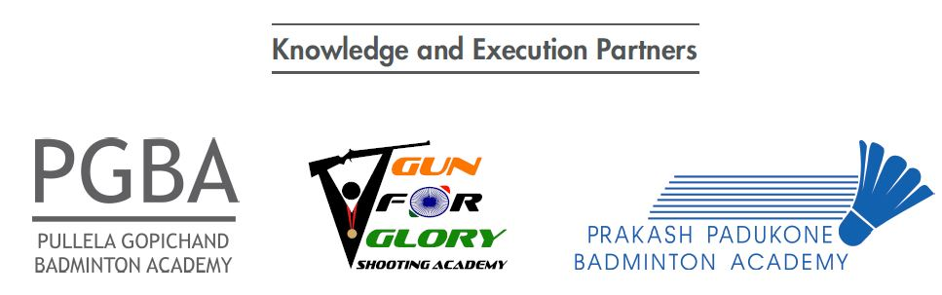
After filling the form please email the soft copy to cep@olympicgoldquest.com
  OGQ Coaches Excellence Program  BADMINTON – ROUND 1  APPLICATION FORM – CLASS Of 2021 | A BRIEF NOTE:  Olympic Gold Quest (OGQ) is happy to invite applications from Badminton coaches for the third edition of the Coaches Excellence Programme (CEP). CEP intends to nurture world-class Indian coaches who can produce champions for India. Selected coaches will be empowered (through education, best global practices, access to top experts) to ensure that they are at par with best international coaches. If you want to see yourself as a leading coach in the country, we would be happy to have you on-board for this wonderful journey of excellence.

PERSONAL DETAILS

Full Name:

Gender:

Current Location:

Age:

Mobile Number:

Email Address:

EDUCATION QUALIFICATIONS:
Detail | Year | Name of Degree | Name of the Institute | City | % marks

Class XII

Graduation
(If applicable)

Post-graduation
(If applicable)

Have you applied to the OGQ Coaches Excellence Program before?
Yes No

YOUR EXPERIENCE AS AN ATHLETE

- Your career as an athlete spanned how many years?
- <1 year
- 1-5 years
- 6-10 years
- 11-15 years
- >15 years

- What were your key achievements as an athlete? What is the highest level that you have played (International/National/State/District)?

- Who are the coaches you trained under and for how long?

YOUR EXPERIENCE AS A COACH

- How many years of coaching experience do you have?
- <1 year
- 1-5 years
- 6-10 years
- 11-15 years
- >15 years

- Do you have formal training or a certificate in coaching?
Yes No

- If yes, please share details of the courses/ certifications completed in Coaching.

- How many athletes are you coaching currently and what is their level?
Sub-Junior | Junior | Senior | Total

- List key achievements and rankings ((International / National) of some of your top athletes.

YOUR WORKPLACE

- What is your current employment status? (tick one)
- Full Time with Govt Job
- Full Time with Private Job
- Part Time Job and Part Time Coaching
- Full Time Coaching Driving Income
- Any Other (Please mention)

- Which academy/ organization are you currently associated with? Is this organization part of a school/ college/ academy?

- Which academy/organization/ institute/ school have you previously been associated with as a coach? (Mention all):

- How many hours in a day do you coach?

- How many of the following facilities are available at your current coaching infrastructure? What is the number of physios, medical, fitness, support staff do you currently have and are working with regularly?

Number of Coaches (Including you)
Mention any other team members or support staff in your academy (Physio, Trainer, Nutritionist, Administration, etc.)
No. of Courts
Gym
Hostel Facility available for players
(Mention capacity)
Other facilities available:

Your Interest in the OGQ Coaches Excellence Program

- Why do you want to join CEP?

- Name up to 5 key areas you would like to learn about during CEP.

- Do you have any questions for us?

USE THIS SPACE TO WRITE ADDITIONAL COMMENTS:

